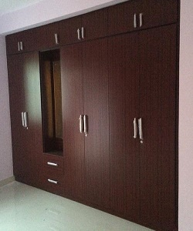

Wood creation Cupboard

$104.24

Availability: In stock

Description

Modern, Simple and clean lines Wood creation cupboard. Unique wood 3 sections wardrobe with drawers and a mirror.